Third Party SDK Sample
1.0 Introduction
This sample app is used to scan Eddystone and iBeacon devices and get promotion information getting from server.

2.0 Requirement
- This Sample app supports Android API Level above 18(Android OS 4.3)
- Device must have Bluetooth feature.
- Internet must be enabled.

3.0 Sample application description
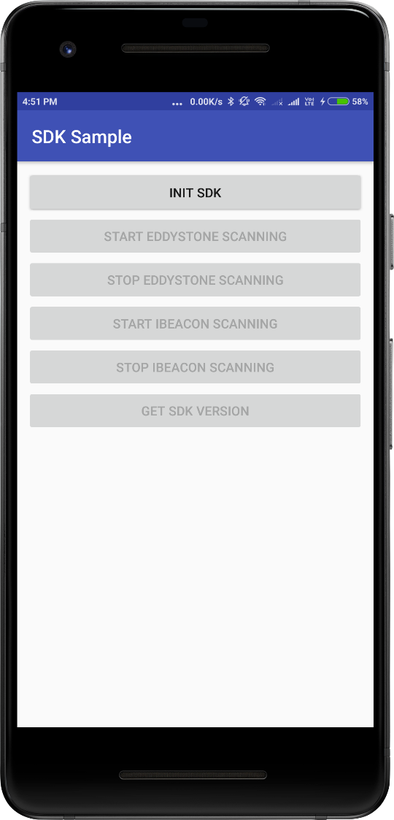

- Init SDK
This button is used to initialize third party SDK. Once it will click start/stop iBeacon and Eddystone scanning button getting enable.

- Start Eddystone Scanning
This button is used to star Eddystone device scanning. Once registered device will found we are displaying notification and when user click on notification we are updating to server.

- Stop Eddystone Scanning
This button is used to stop Eddystone scanning.

- Start iBeacon Scanning
This button is used to start iBeacon device scanning. Once registered device will found we are displaying notification and when user click on notification we are updating to server.

- Stop iBeacon Scanning
This button is used to stop iBeacon device scanning.

- Get SDK Version
When user click on this button we are displaying SDK version in toast (One type of dialog in Android) in bottom of screen.

- Get File Path
When user click on this button we are displaying SDKLogs.txt and SDKSampleLogs.txt file path in toast (One type of dialog in Android) in bottom of screen.

Note: Please allow all the required permission in application. And whenever scanning/task will be done send us two text file SDKSampleLogs.txt and SDKLogs.txt file for find out cause of issue.

