

Sollatek Phone App User Manual V1.0
Content
1 PURPOSE 3
2 SCOPE 3
3 DEFINATION(S) and ABBREVIATION(S) 4
4 REFERENCE(S) 4
5 DOCUMENT HISTORY 4
6 INTRODUCTION 5
7 INSTALLATION AND LOGIN TO PHONE APP 6
8 SCANNING SCREEN OF PHONE APP 7
9 COOLER LIVE IMAGE 11
10 DEVICE CONFIGURATION PARAMETERS 12
10.1 SET DATE TIME 12
10.2 ENABLE/ DISABLE MULTILEVEL PASSWORD 13
10.3 SET HEALTH EVENT INTERVAL 14
10.4 SET ENVIRONMENT EVENT INTERVAL 15
10.5 SET ADVERTISEMENT INTERVAL OF MAIN ADVERTISEMENT FRAME 16
10.6 SET TX POWER OF MAIN ADVERTISEMENT FRAME 17
10.7 SET ENERGY SAVING ADVERTISEMENT INTERVAL AND TX POWER OF MAIN ADVERTISEMENT FRAME 18
10.8 SET DIAGNOSTIC EVENT INTERVAL 19
10.9 SET BATTERY TIMEOUT MODE INTERVAL 20
10.10 CONTROL STAND BY MODE 21
10.11 RESTART DEVICE 22
10.12 FACTORY RESET DEVICE 23
10.13 STOP ADVERTISEMENT 24
10.14 SET SH APN 25
10.15 SET SH URL 26
10.16 SET MAINS POWER TASK INTERVAL 27
10.17 SET BATTERY POWER TASK 28
10.18 COOLER LOCK DAYS 29

11 DIFFERENT BLUETOOTH FRAMES AND CONFIGURATION 30
11.1 IBEACON FRAME CONFIGURATION 30
11.1.1 ENABLE/DISABLE IBEACON FRAME 30
11.1.2 SET UUID 31
11.1.3 SET MAJOR, MINOR AND RSSI 32
11.1.4 SET ADVERTISEMENT INTERVAL AND TX POWER 33
11.1.5 SET ADVERTISEMENT INTERVAL AND TX POWER FOR ENERGY SAVING MODE 34
11.2 EDDYSTONE UID CONFIGURATION 35
11.2.1 ENABLE/DISABLE UID FRAME 35
11.2.2 SET UID NAMESPACE AND INSTANCE 36
11.2.3 SET ADVERTISEMENT INTERVAL AND TX POWER 37
11.2.4 SET ADVERTISEMENT INTERVAL AND TX POWER FOR ENERGY SAVING MODE 38
11.3 EDDYSTONE URL CONFIGURATION 39
11.3.1 ENABLE/DISABLE URL FRAME 39
11.3.2 SET URL 40
11.3.3 RESET URL 41
11.3.4 SET ADVERTISEMENT INTERVAL AND TX POWER 42
11.3.5 SET ADVERTISEMENT INTERVAL AND TX POWER FOR ENERGY SAVING MODE 43
11.4 EDDYSTONE TLM CONFIGURATION 44
11.4.1 ENABLE/DISABLE TLM FRAME 44
11.4.2 SET ADVERTISEMENT INTERVAL AND TX POWER 45
11.4.3 SET ADVERTISEMENT INTERVAL AND TX POWER FOR ENERGY SAVING MODE 46
12 LOGGED EVENT TYPES 47
13 CONTROLLER CONFIGURATION PARAMETERS 51
14 CLOUD TAB 54
15 FIRMWARE UPGRADE OVER THE AIR (DFU) 55
16 STM FIRMWARE UPGRADE OF CONTROLLER 57
17 RUN VIRTUAL HUB FOR EVENT DATA UPLOAD ON CLOUD 58
18 FILTER PARTICULAR DEVICE TYPE 60
19 LOGOUT APPLICATION 61

1 PURPOSE
To understand operation and basic functionality of Sollatek Devices using sollatek android phone application.

2 SCOPE
Useful for tester and final user.

3 DEFINATION(S) and ABBREVIATION(S)
NAME | ABBREVIATION
DFU | Direct Firmware Upgrade
BLE | Bluetooth Low Energy

4 REFERENCE(S)
DOCUMENT NO | TITLE

5 DOCUMENT HISTORY
Version | Date completed | Written by | Reviewed by | Approved by
1.0 | 9thDecember, 2019 | Nirali Solanki | Bipin Patel
 | - Initial Version

6 INTRODUCTION
- Sollatek devices are BLE enabled and connected to controller module to see instantaneous real time data on phone screen as well as it logs temperature, voltage, power events, operation status change, relay status.

7 INSTALLATION AND LOGIN TOPHONE APP
- Install App and click on “Sollatek” application icon to launch application.

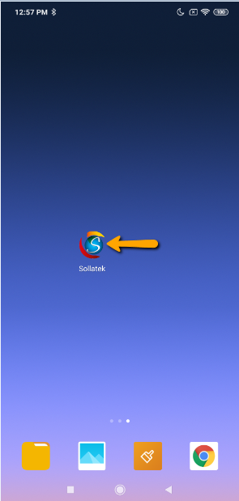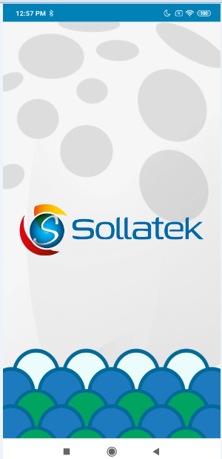

- If user is login first time then it will ask for Email (User id), Password and Server. Use valid credential for login and appropriate server and click on LOGIN button.
Note: Please ensure Bluetooth & Internet connection (via Mobile Wi-Fi or Mobile Data) must be enabled in Phone otherwise login will be failed.

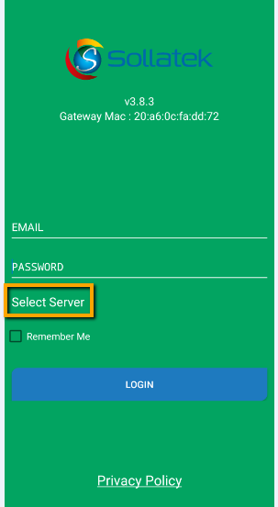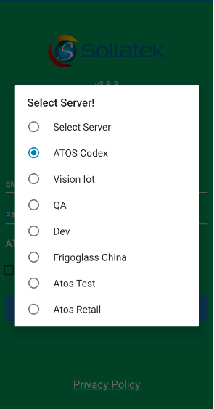

8 SCANNING SCREEN OF PHONE APP
- After successful login, application will direct to BLE scanning screen as shown below.
- Scanning screen will show available sollatek device list. User can identify particular device by its MAC address, Serial number or Cooler ID if Cooler ID is stored into device otherwise it will show “NA” for Cooler ID.

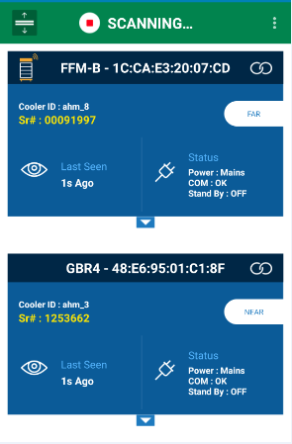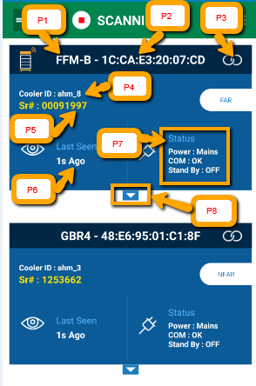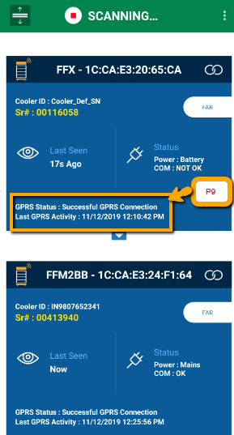
Smart device Gateway device
P1: Device Type
P2: Device MAC Address
P3: To make connection with device
P4: Cooler ID. If it shows “NA” then it means no Cooler ID entered into Device.
P5: Device Serial#
P6: Last Seen: When phone app seen device at last
P7: Status of device which include following
- Power Status: Mains/Battery
- UART Communication with Controller: OK/Not OK
(App will show the Message “No Communication” when user try to read controller parameters)
- Standby Mode: ON/OFF (When it is ON, device will not communicate with controller and so no event logging occurs)
P8: To expand parameters screen. Parameter screen will not expand if device is in following state.
(Battery mode)/ (communication is not OK)/ (Standby is ON).
P9: It Shows the Last Activity of GPRS as well as GPRS Status also.

NOTE: Standby mode functionality only supported for GBR-1, GBR-3, GBR-4, FFM-B, JEA and FCA3BB devices.

- After expansion of screen, different screen will appear for different device type.

- FFMB/GBR3/JEA/FFM2BB/GMC4/FFX:

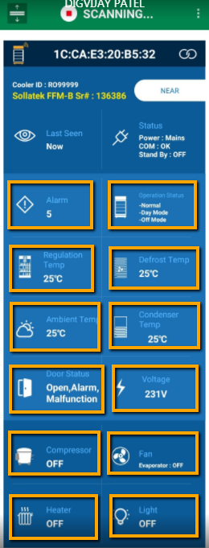

P2
P1

P3
P10
P12
P8
P6
P4
P11
P5
P9
P7

P1: Total Number of Alarm(s) reported by controller
P2: Operation Status reported by controller
P3: Regulation Probe Temperature. If Regulation probe is faulty then it will show “Faulty”. If Regulation Probe is not configured then we show “NA” there.
P4: Defrost Probe Temperature. If Defrost probe is faulty then it will show “Faulty”. If Defrost Probe is not configured then we show “NA” there.
P5: Ambient Probe Temperature. If ambient probe is faulty then it will show “Faulty”. If Ambient Probe is not configured then we show “NA” there.
P6: Condenser Probe Temperature. If Condenser probe is faulty then it will show “Faulty”. If Condenser Probe is not configured then we show “NA” there. If Condenser Temperature is high then it will show “High” with temperature value. If Condenser Temperature is low then we show “Low” with temperature value.
P7: Door Status (Open/Close). If Door Alarm is high then It will show “Alarm” also. If Door Malfunction is high then It will show “Malfunction” also.
P8: Average Input voltage. It will also show “High” or “Low” with value of voltage according to High or Low voltage condition.
P9: Compressor Status
P10: Evaporator Fan Status
P11: Heater Status
P12: Light Status

- GBR1/GBR4/FCAx3-BB/FDE:

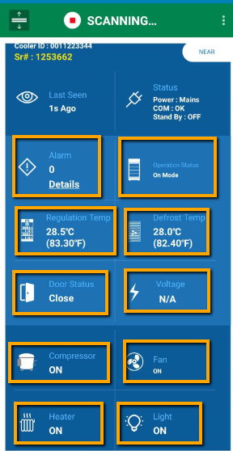
P10
P9
P8
P7
P6
P5
P4
P2
P3
P1

P1: Total Number of Alarm(s) reported by controller
P2: Operation Status reported by controller
P3: Regulation Probe Temperature. If Regulation probe is faulty then it will show “Faulty”. If Regulation Probe is not configured then we show “NA” there.
P4: Defrost Probe Temperature. If Defrost probe is faulty then it will show “Faulty”. If Defrost Probe is not configured then we show “NA” there.
P5: Door Status (Open/Close). If Door Alarm is high then It will show “Alarm” also. If Door Malfunction is high then It will show “Malfunction” also.
P6: Voltage if provided by controller
P7: Compressor Status
P8: Fan Status
P9: Heater Status
P10: Light Status

9 COOLER LIVE IMAGE
- On scanning window, there is button on left side of MAC address as shown in figure. By clicking on it, User can see a live cooler Image.
- This live image contains Cooler Sr#, Ambient temperature, Evaporator temperature, Cooler air temperature, condenser temperature, Heater status, Evaporator Fan status, Light status, Door status, Power Status with Voltage.

NOTE: Cooler Image functionality is not available for Sollatek GBR4 and FCA×3BB as of now.

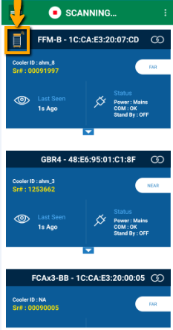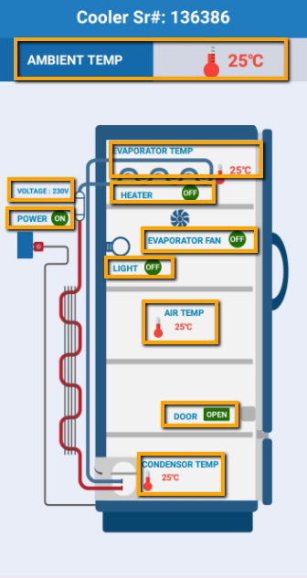

10 DEVICE CONFIGURATION PARAMETERS
- After connection with device, following screen appears first which shows configuration parameter of device.

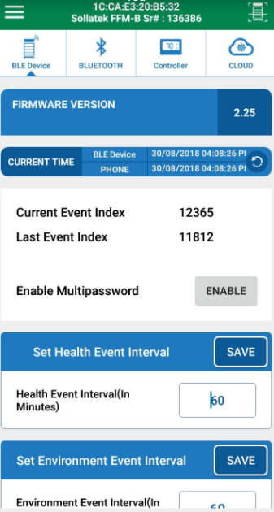
- After connection, under 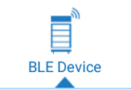 Tab, user can set following parameters.
- Set Date Time
- Enable/disable Multilevel password
- Set Health Event Interval
- Set Environment Event Interval
- Set Advertisement Interval
- Set Tx Power
- Set Energy Saving Advertisement Interval and Tx Power
- Diagnostic event interval
- Battery mode timeout interval
- Standby Mode ON/OFF
- Restart Device
- Factory Reset Device
- Stop Advertisement
- Set SH APN
- Set SH URL
- Set Mains Power Task Interval
- Set Battery Power Task
- Cooler Lock Days

10.1 SET DATE TIME

- Click on symbol shown in figure by yellow arrow to set current date time.

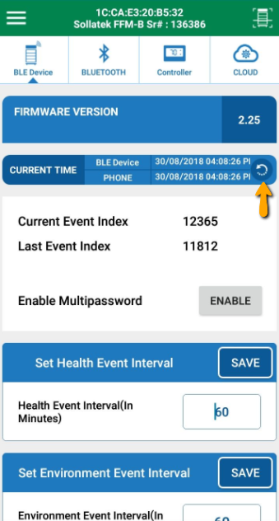

10.2 ENABLE/ DISABLE MULTILEVEL PASSWORD

- Click on button as shown in figure for enable/disable multilevel password
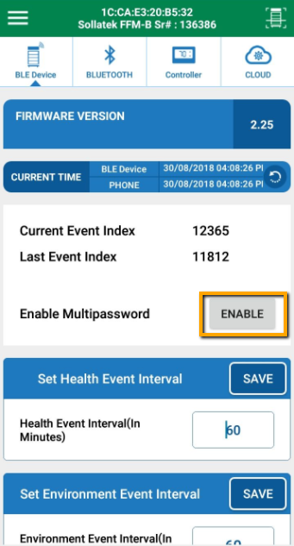

10.3 SET HEALTH EVENT INTERVAL

- User can set Health event Interval in range of 1 to 240 minutes.
- Health event logs Regulation temperature, Defrost temperature and Condenser temperature of cooler.
- After changing value, click on save button to save it.

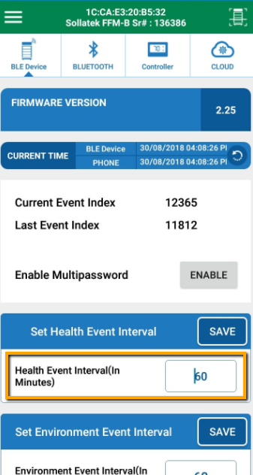

10.4 SET ENVIRONMENT EVENT INTERVAL

- User can set Environment event Interval in range of 1 to 240 minutes.
- Environment event logs ambient temperature and cooler Voltage.
- After changing value, click on save button to save it.

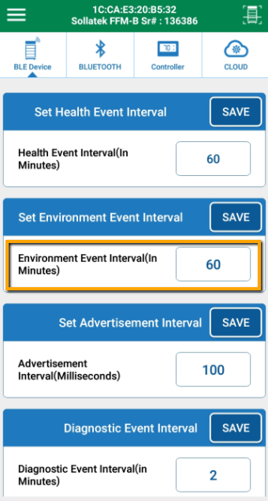

NOTE: Environment event interval is applicable to FFM-B, GBR-3, FFX, GMC-4, FFM-2BB and JEA.

10.5 SET ADVERTISEMENT INTERVAL OF MAIN ADVERTISEMENT FRAME
- User can set BLE Advertisement Interval in range of 20 to 10000 millisecond.
- After changing value, click on save button to save it.

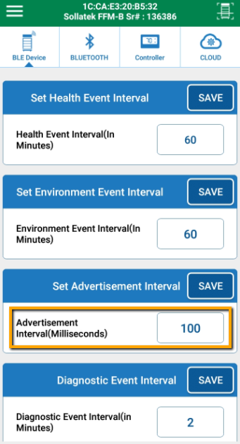

10.6 SET TX POWER OF MAIN ADVERTISEMENT FRAME

- User can select BLE Tx power for Normal advertisement with option of -20, -16, -12, -8, -4, 0 and 4 dBm.
- After changing value, click on save button to save it.

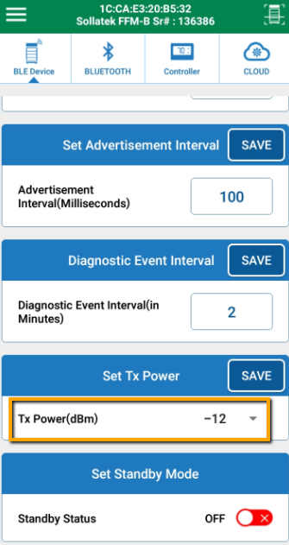

10.7 SET ENERGY SAVING ADVERTISEMENT INTERVAL AND TX POWER OF MAIN ADVERTISEMENT FRAME

- BLE Main frame advertisement interval and Tx power can be modified by clicking on respective raw as per shown in figure.
- Range for advertisement interval is from 20 to 10000 millisecond.
- Available settings for Tx power are -20, -16, -12, -8, -4, 0 and 4 dBm.
- Please press on SAVE button after setting.

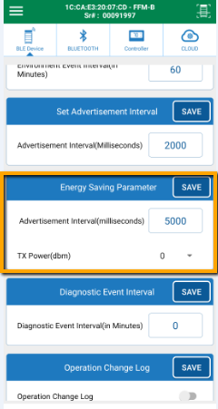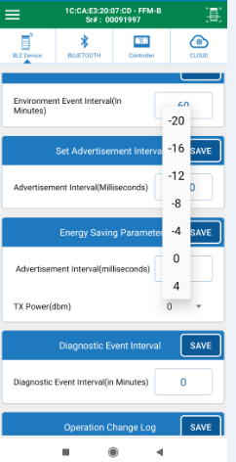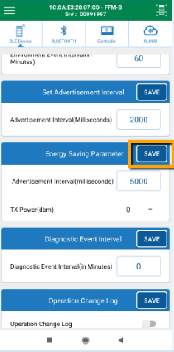

NOTE: Energy saving functionality is applicable to FFM-B, GBR1, GBR3, GBR4, JEA and FCA×3BB.

10.8 SET DIAGNOSTIC EVENT INTERVAL

- User can set Diagnostic event Interval in range of 0 to 240 minutes.
- Diagnostic event logs FFA module activities.
- After changing value, click on save button to save it.

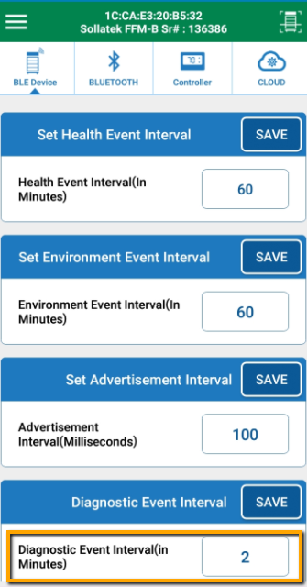

NOTE: Diagnostic event interval is applicable for FFM-B, FFM-2BB, and GMC-4.

10.9 SET BATTERY TIMEOUT MODE INTERVAL

- User can select the battery time out mode in 0 to 1440 minutes.
- Battery time out mode is used for Device Advertisement time in Battery mode.
- If User set the 2min in battery timeout mode then Device advertises 2min in Battery mode

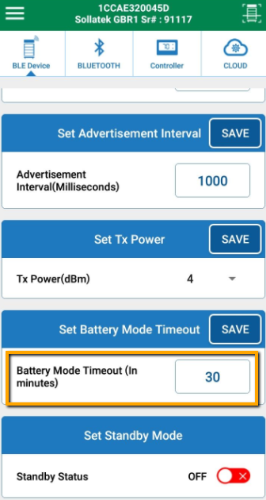

NOTE: Battery timeout mode functionality is applicable to GBR1, GBR3, GBR4, JEA and FCAx3-BB.

10.10 CONTROL STAND BY MODE
Device can be operated into standby mode or normal mode.
To Enable/Disable Standby mode
- User can ON/OFF standby mode here
- If standby mode is ON then it will stop event logging in memory and also don’t communicate with FFA module.
- If standby mode is OFF then it will start event logging and communicate with controller again. This is a Normal mode.

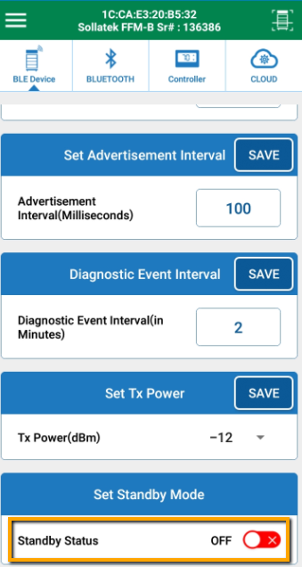

NOTE: Standby mode functionality is supported for FFM-B, GBR1, GBR3, GBR4, JEA and FCAx3-BB.

10.11 RESTART DEVICE

- User can restart (power cycle) the device by clicking on following sequence.

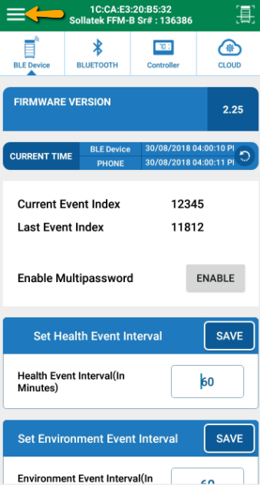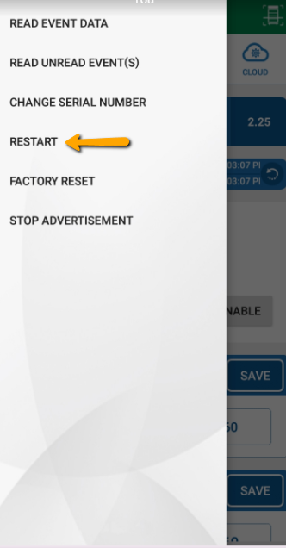

10.12 FACTORY RESET DEVICE

- User can restore all settings to factory default by clicking on following sequence.
- By factory reset, all logged event data will be erased and device will start event logging from Initial.

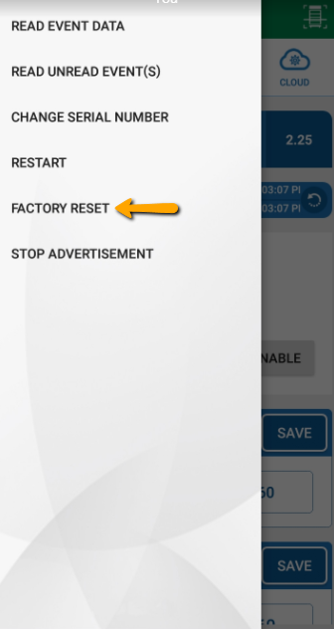

10.13 STOP ADVERTISEMENT

- User can stop advertisement of the device by clicking on following sequence.
- Advertisement can be started again automatically when Mains supply given to the device again.

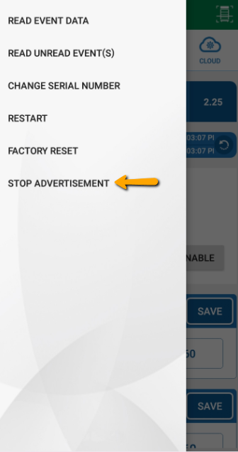

SET SH APN

- User can change the APN by using the “SET SH APN” Command
- Please press on SET button after setting

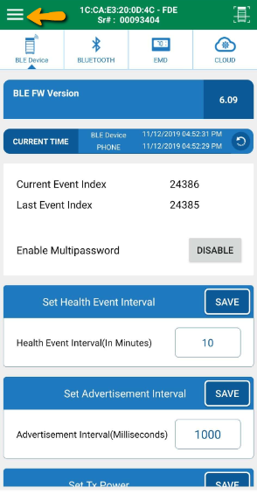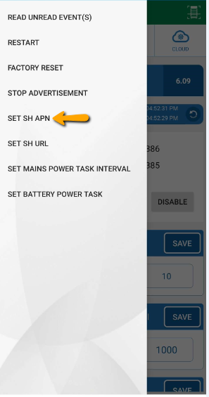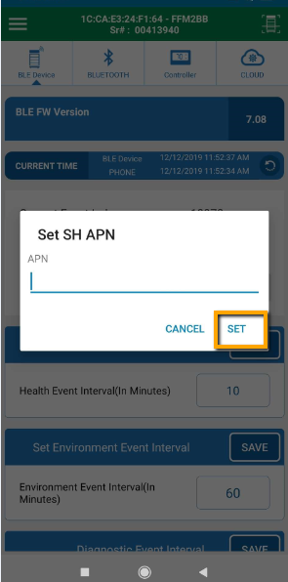

NOTE: This parameter is supported by FFM2BB, FDE, GMC-4 and FFX.

SET SH URL

- User Can Change the Server by using the “SET SH URL”.
- Please press on SET button after setting

NOTE: The Command needs the 100% Accuracy, If the user makes any error when set the command then the device got default Device SR#(1138575) then Device does not longer to connect with the Server or connect using App.

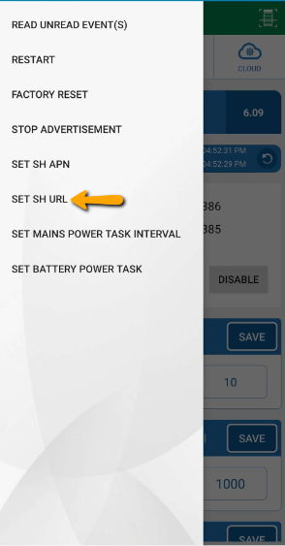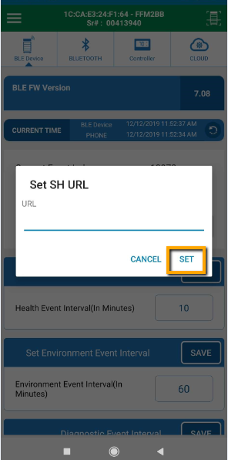

NOTE: This parameter is supported by FFM2BB, FDE, GMC-4 and FFX.

SET MAINS POWER TASK INTERVAL

- User can Update the GPRS and Wi-Fi Interval Using this Command Menu>>Set Mains Power task Interval.
- If User Need to Change the Interval of Device Communication with the server or get Wi-Fi Location time then Use same Command.
- Please press on SET button after setting

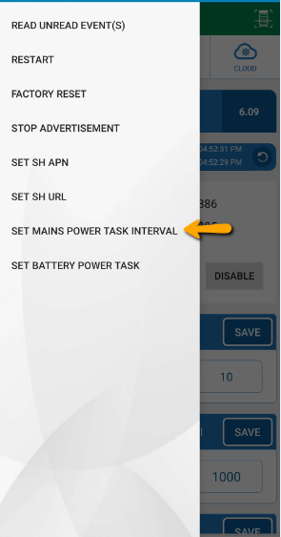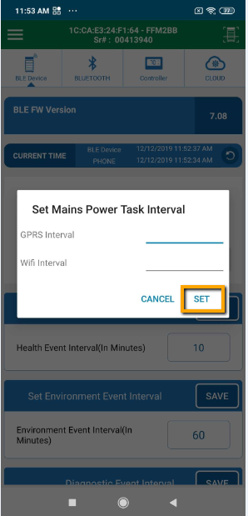

NOTE: This parameter is supported by FFM2BB, FDE, GMC-4 and FFX.

SET BATTERY POWER TASK

- User can Update the GPRS or Wi-Fi Interval without Motion Using this Command
- User can Change GPRS or Wi-Fi interval with Motion Interval and Motion Stop Interval using this Command, Menu>>Set Battery Power task Interval.
- Please press on SET button after setting

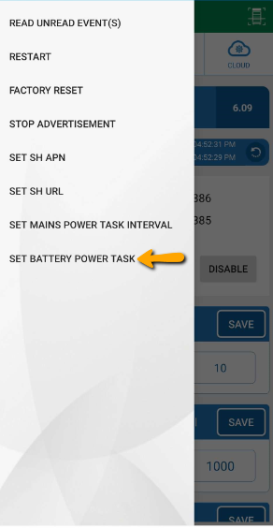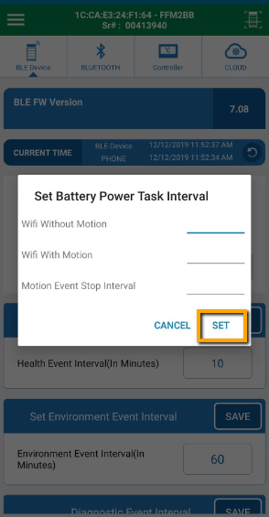

NOTE: This parameter is supported by FFM2BB, FDE, GMC-4 and FFX.

SET COOLER LOCK DAYS

- User can set Cooler Lock days in range of 0 to 365 Days.
- After changing value, click on save button to save it.

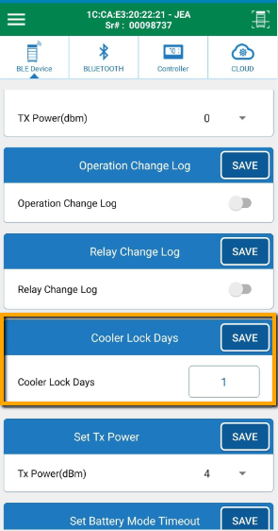

NOTE: This parameter is supported by JEA and FFX.

11 DIFFERENT BLUETOOTH FRAMES AND CONFIGURATION

IBEACON FRAME CONFIGURATION

11.1.1 ENABLE/DISABLE IBEACON FRAME
- iBeacon frame can be enabled/disabled as per shown in figure.
- Please press on SAVE button after setting.

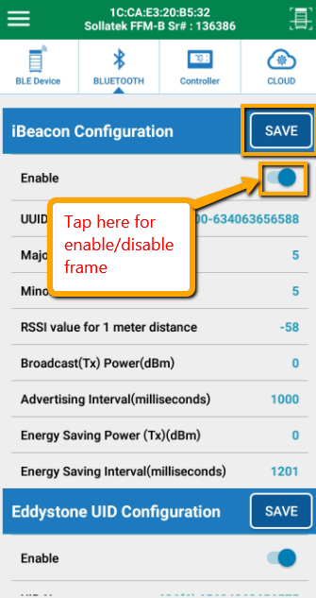

11.1.2 SET UUID

- iBeacon UUID can be modified by clicking on UUID raw as per shown in figure.
- UUID should be 16 byte long.
- Please press on SAVE button after setting.

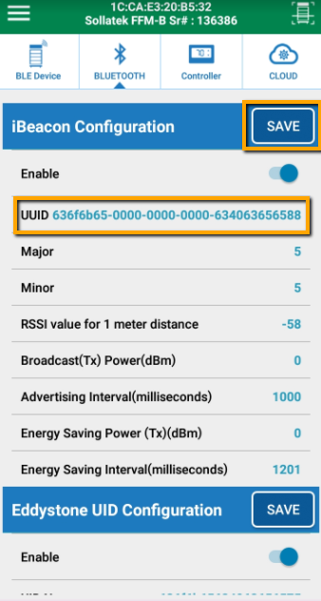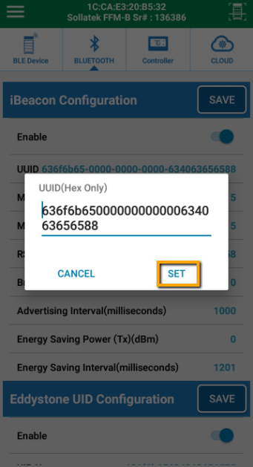

11.1.3 SET MAJOR, MINOR AND RSSI

- iBeacon Major, Minor and RSSI can be modified by clicking on respective raw as per shown in figure.
- Range for Major and Minor is from 1 to 65535.
- Range for RSSI is from -128 to 127 dbm.
- Please press on SAVE button after setting
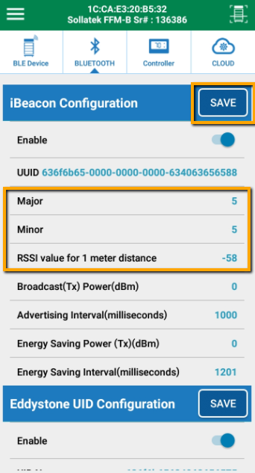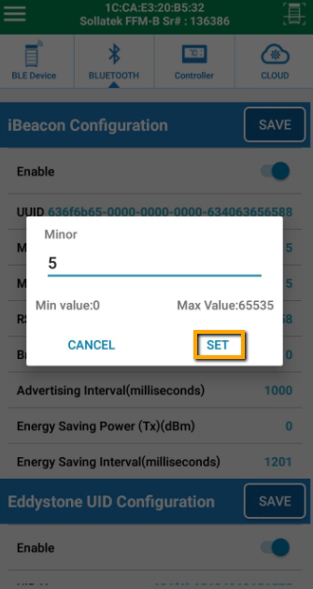

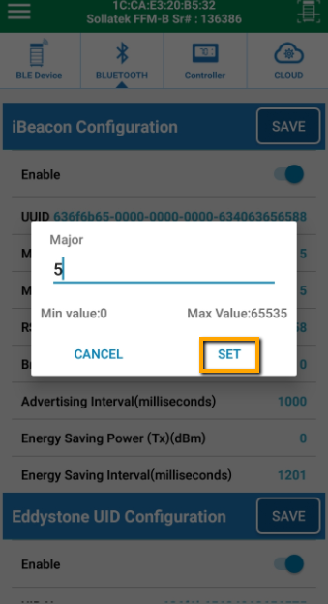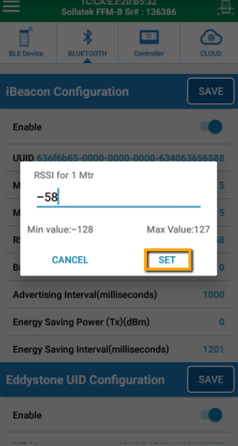

11.1.4 SET ADVERTISEMENT INTERVAL AND TX POWER

  - iBeacon advertisement interval and Tx power can be modified by clicking on respective raw as per shown in figure.
  - Range for advertisement interval is from 20 to 10000 millisecond.
  - Available settings for Tx power are -20, -16, -12, -8, -4, 0 and 4 dBm.
  - Please press on SAVE button after setting.

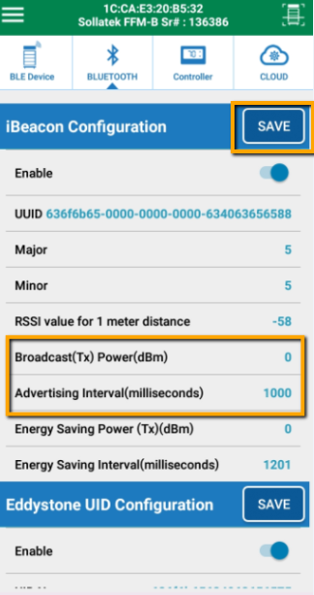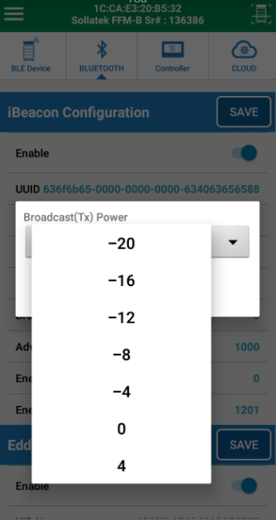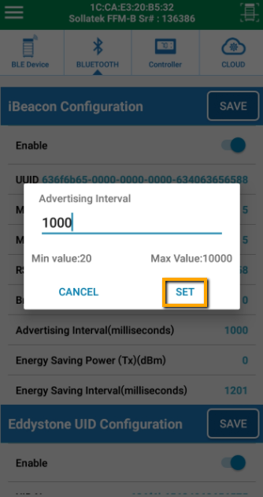

11.1.5 SET ADVERTISEMENT INTERVAL AND TX POWER FOR ENERGY SAVING MODE
- In Energy saving mode, User can select high advertisement period and low Tx power to save energy of device mainly during on battery mode.
- Advertisement interval and Tx power can be modified by clicking on respective raw as per shown in figure.
- Range for advertisement interval is from 20 to 10000 millisecond.
- Available settings for Tx power are -20, -16, -12, -8, -4, 0 and 4 dBm.
- Please press on SAVE button after setting.

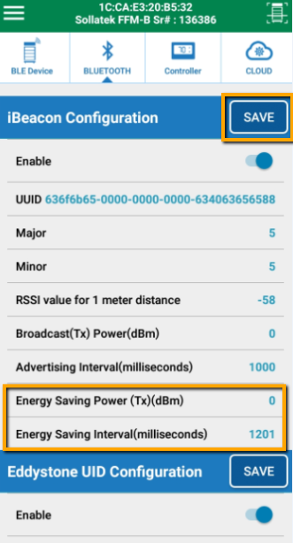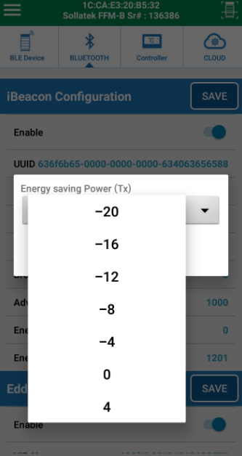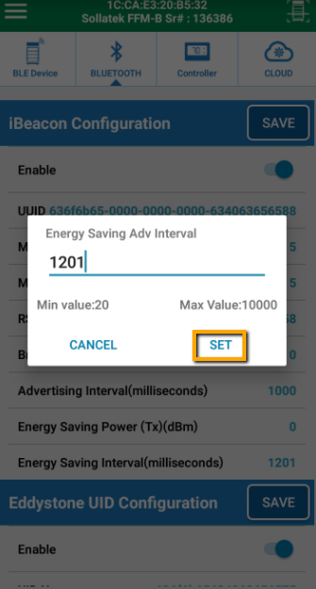

NOTE: After modification of settings, Click on SAVE button is compulsory to save modified parameters in device.

11.2 EDDYSTONE UID CONFIGURATION

11.2.1 ENABLE/DISABLE UID FRAME
- Eddystone UID frame can be enabled/disabled as per shown in figure.
- Please press on SAVE button after setting.

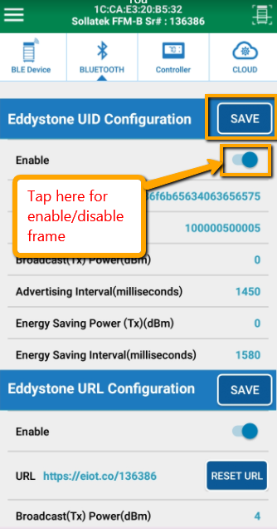

11.2.2 SET UID NAMESPACE AND INSTANCE

- Eddystone UID Namespace and Instance can be modified by clicking on respective raw as per shown in figure.
- Namespace should be 10 byte long and Instance should be 6 byte long.
- Please press on SAVE button after setting.

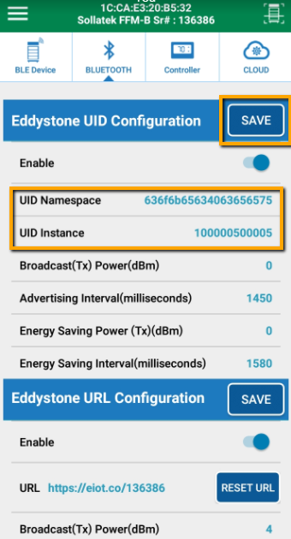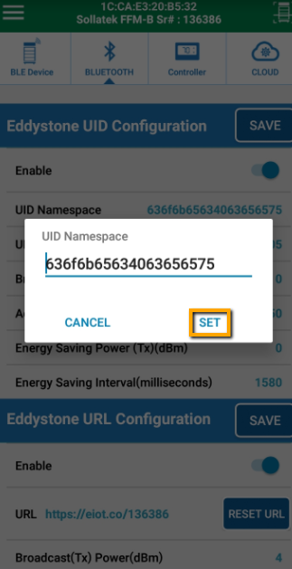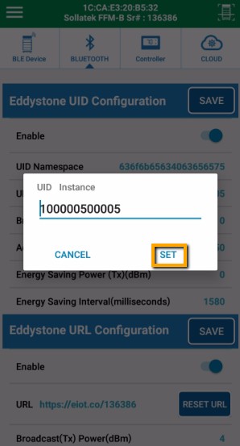

11.2.3 SET ADVERTISEMENT INTERVAL AND TX POWER

- Advertisement interval and Tx power can be modified by clicking on respective raw as per shown in figure.
- Range for advertisement interval is from 20 to 10000 millisecond.
- Available settings for Tx power are -20, -16, -12, -8, -4, 0 and 4 dBm.
- Please press on SAVE button after setting.

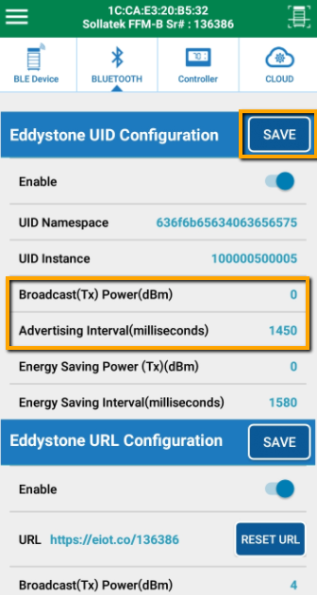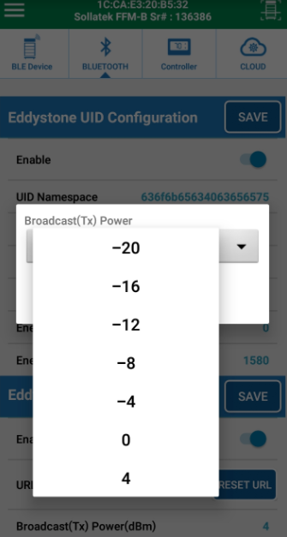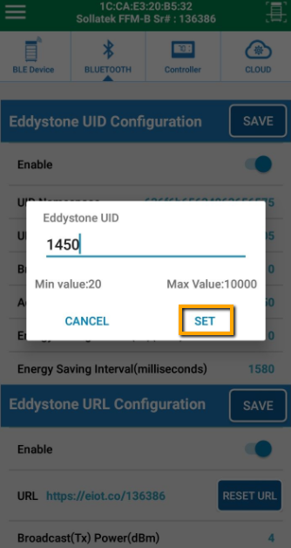

11.2.4 SET ADVERTISEMENT INTERVAL AND TX POWER FOR ENERGY SAVING MODE

- In Energy saving mode, User can select high advertisement period and low Tx power to save energy of device mainly during on battery mode.
- Advertisement interval and Tx power can be modified by clicking on respective raw as per shown in figure.
- Range for advertisement interval is from 20 to 10000 millisecond.
- Available settings for Tx power are -20, -16, -12, -8, -4, 0 and 4 dBm.
- Please press on SAVE button after setting.
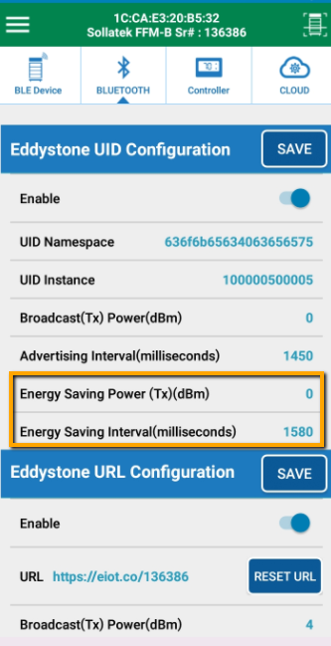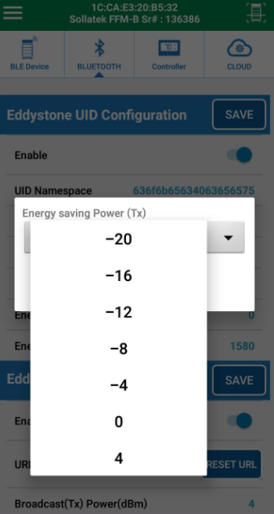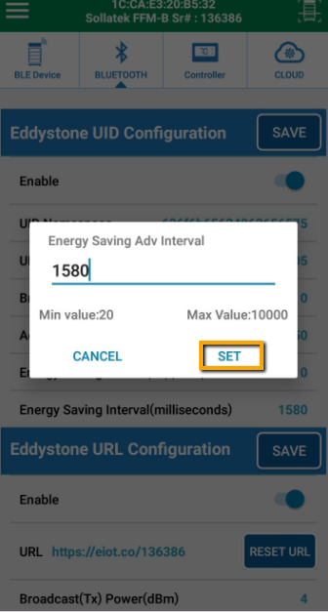

NOTE: After modification of settings, Click on SAVE button is compulsory to save modified parameters in device.

11.3 EDDYSTONE URL CONFIGURATION

11.3.1 ENABLE/DISABLE URL FRAME
- Eddystone URL frame can be enabled/disabled as per shown in figure.
- Please press on SAVE button after setting.

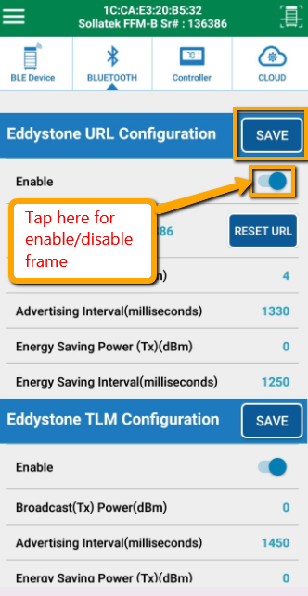

SET URL

- Eddystone URL can be can be modified by clicking on respective raw as per shown in figure.
- Please press on SAVE button after setting.

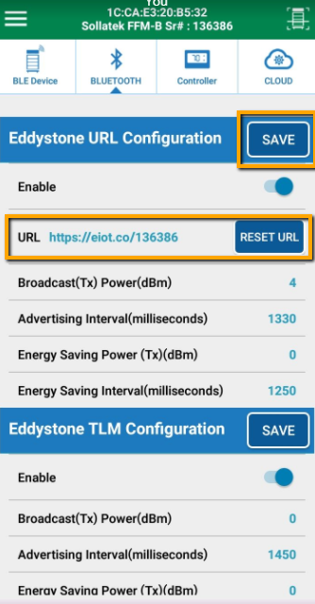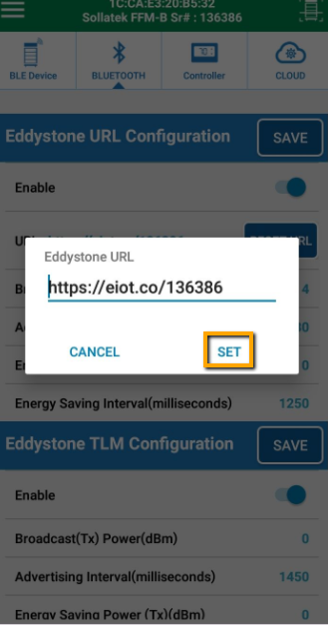

RESET URL

- User can set URL to default factory setting by clicking on “RESET URL” button as shown in figure.
- Default URL format is (https://eiot.com/serialnumber)

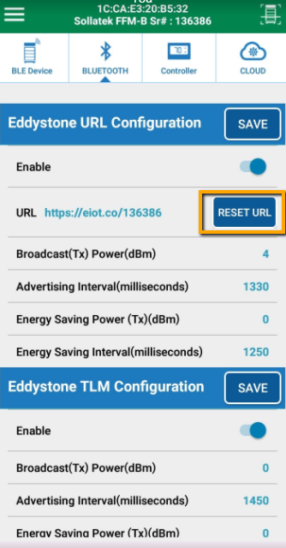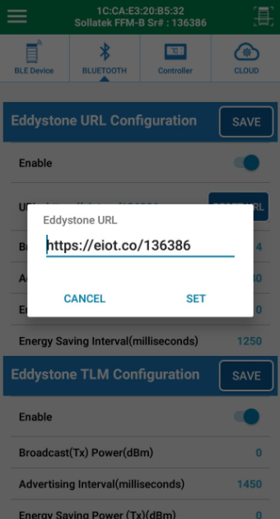

SET ADVERTISEMENT INTERVAL AND TX POWER

- Advertisement interval and Tx power can be modified by clicking on respective raw as per shown in figure.
- Range for advertisement interval is from 20 to 10000 millisecond.
- Available settings for Tx power are -20, -16, -12, -8, -4, 0 and 4 dBm.
- Please press on SAVE button after setting.

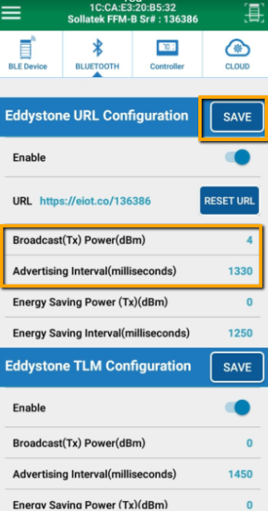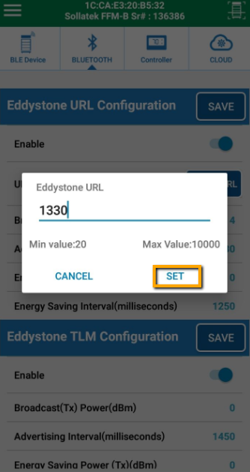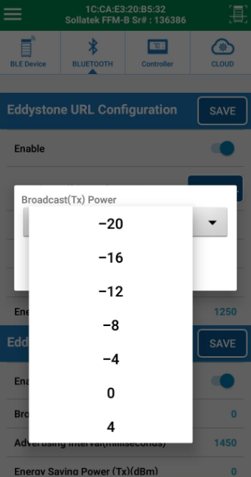

SET ADVERTISEMENT INTERVAL AND TX POWER FOR ENERGY SAVING MODE

- In Energy saving mode, User can select high advertisement period and low Tx power to save energy of device mainly during on battery mode.
- Advertisement interval and Tx power can be modified by clicking on respective raw as per shown in figure.
- Range for advertisement interval is from 20 to 10000 millisecond.
- Available settings for Tx power are -20, -16, -12, -8, -4, 0 and 4 dBm.
- Please press on SAVE button after setting

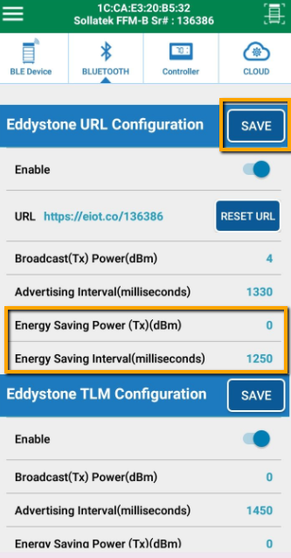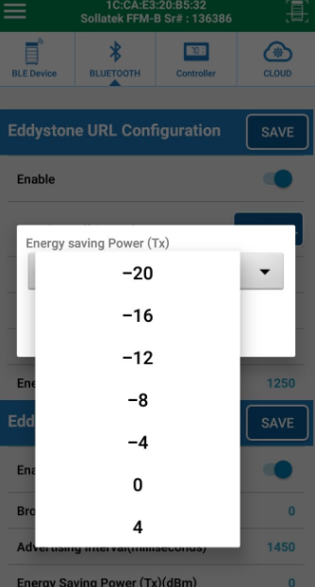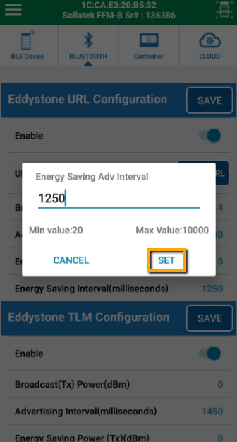

NOTE: After modification of settings, Click on SAVE button is compulsory to save modified parameters in device

EDDYSTONE TLM CONFIGURATION

ENABLE/DISABLETLM FRAME
- Eddystone TLM frame can be enabled/disabled as per shown in figure.
- Please press on SAVE button after setting.

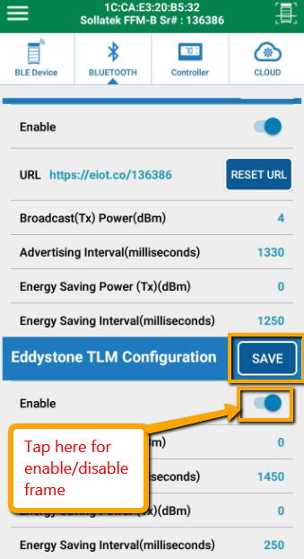

SET ADVERTISEMENT INTERVAL AND TX POWER

- Advertisement interval and Tx power can be modified by clicking on respective raw as per shown in figure.
- Range for advertisement interval is from 20 to 10000 millisecond.
- Available settings for Tx power are -20, -16, -12, -8, -4, 0 and 4 dBm.
- Please press on SAVE button after setting.

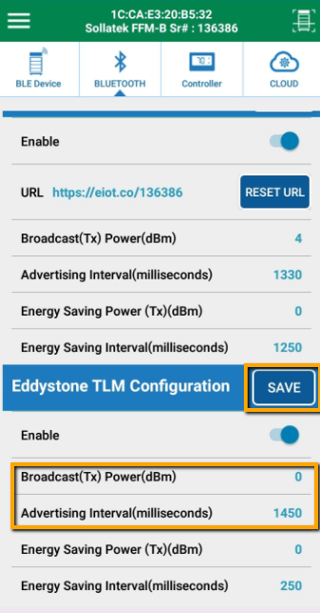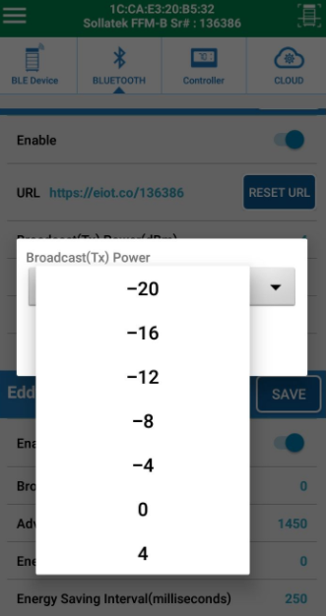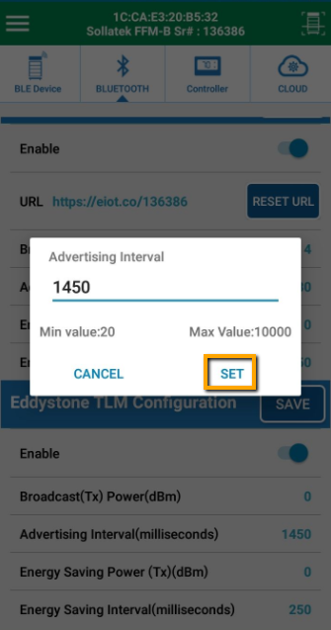

SET ADVERTISEMENT INTERVAL AND TX POWER FOR ENERGY SAVING MODE

- In Energy saving mode, User can select high advertisement period and low Tx power to save energy of device mainly during on battery mode.
- Advertisement interval and Tx power can be modified by clicking on respective raw as per shown in figure.
- Range for advertisement interval is from 20 to 10000 millisecond.
- Available settings for Tx power are -20, -16, -12, -8, -4, 0 and 4 dBm.
- Please press on SAVE button after setting.

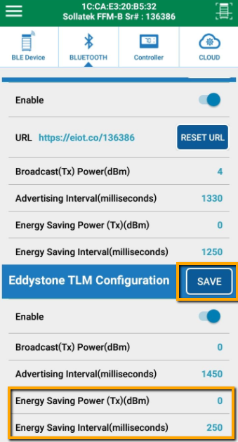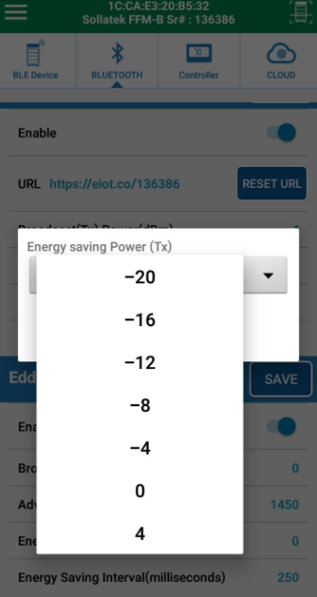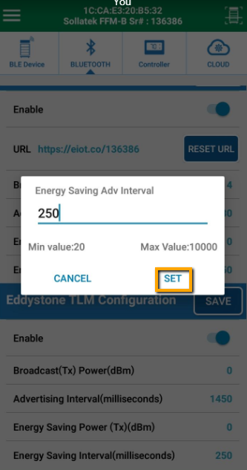

NOTE: After modification of settings, Click on SAVE button is compulsory to save modified parameters in device

12 LOGGED EVENT TYPES
Device can store up to 13056 events in memory. After that it will over write on old event space. Device logs following events.

  - HEALTH EVENT
- Health event contains Regulation temperature, Defrost temperature and Condenser temperature at predefined interval for FFM-B/GBR3/JEA/FFM-2BB/FFX/GMC-4.
- Health event contains Regulation temperature and Defrost temperature at predefined interval for GBR1/GBR4/FCAx3-BB/FDE device.

  - ENVIRONMENT EVENT
- Environment event contains ambient temperature and cooler Voltage at predefined interval. Available in FFM-B/GBR3/JEA/FFX/GMC-4/FM-2BB only.

  - POWER EVENT
- Power event logged with data time when switching occur from Mains power to battery and vice versa.

  - DOOR EVENT
- Door Event logged when door open and close sense.
- Door Event also contains Door timeout event if door remain open for more than 2 minutes

  - ALARM LOG EVENT
- This event logged when any change occurs in Alarm, Operational status and Relay Status.

  - ERROR LOG EVENT
- This event logged when communication failure occurs between controller and sollatek devices.

  - GPS Event
- Device takes GPS coordinate DATA of its position at every regular defined interval. It also takes GPS event after device Movement Event logged. Available in FFX/GMC-4/FM-2BB/FDE only.

  - Movement Event
- This event is logged when device sense any motion in any direction. This Event is logged in both mode Mains and Battery. Available in FFX/GMC-4/FM-2BB/FDE only.

  - GPRS Event
- GPRS event logged when device GPRS connection fail. Available in FFX/GMC-4/FM-2BB/FDE only.

12.10 DIAGNOSTIC EVENT
- Diagnostic event logs Battery Voltage at end of the day for all devices
- It also logs PIR motion counts at every hour for JEA and FFX.
- It also logs run hour for Power, compressor, heater, fan and light at end of the day for FFM-B/GBR3/JEA/FFM2BB/FFX.

12.11 DOWNLOADING EVENT DATA
- User can view logged events by clicking on following screen sequence.

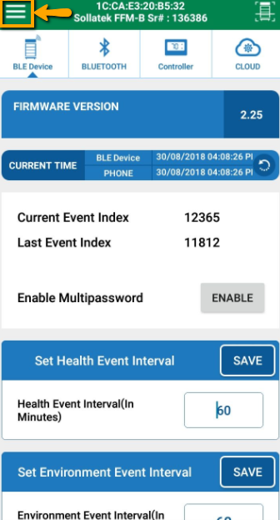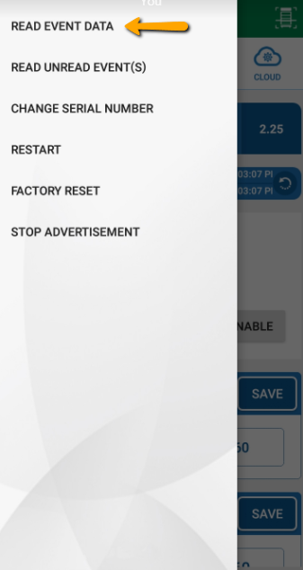
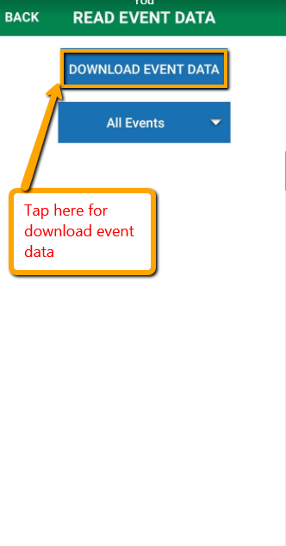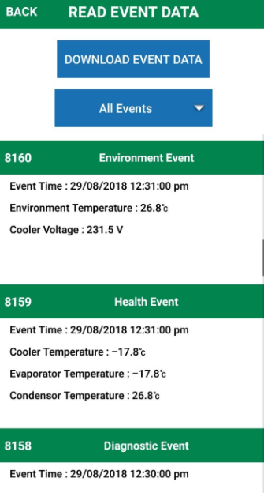

- User can filter different event by clicking on following option.

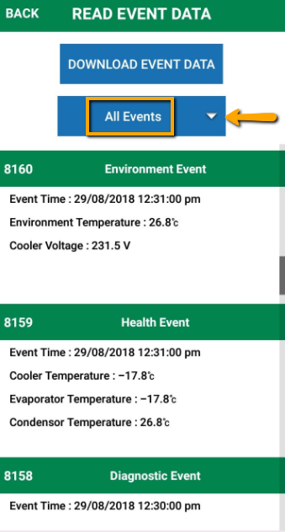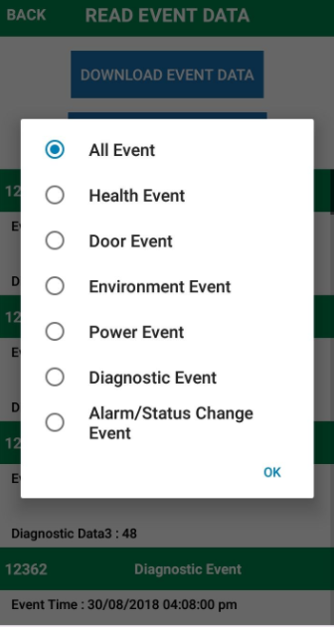

- In Alarm/Status change, there is detail link where user can see status of Event and Alarm bits as shown in below figures.

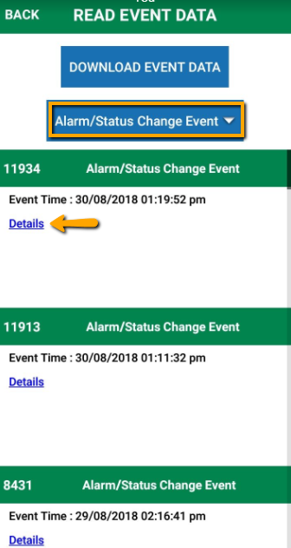

13 CONTROLLER CONFIGURATION PARAMETERS
- After connection, under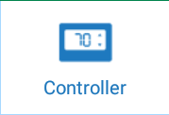 Tab, user can see controller configuration parameters.
- When user switch to controller tab, Phone app first reads all configuration parameter from controller and display to user first.

- For FFM-B/GBR-3/JEA/GMC-4/FFM-2BB/FFX:
- Configuration parameters will be in grouped format. User needs to expand parameters list by clicking on ‘+’.
- If FFA is not connected then it will show Error message
- User can change any parameter by clicking on that parameter. After changing desire value, click on Set tab.

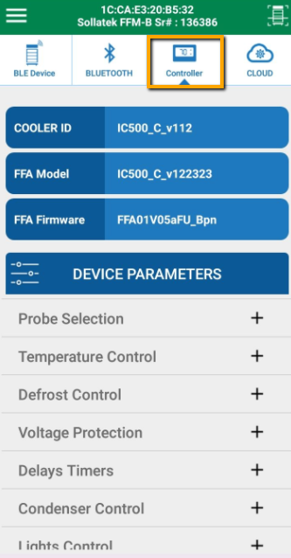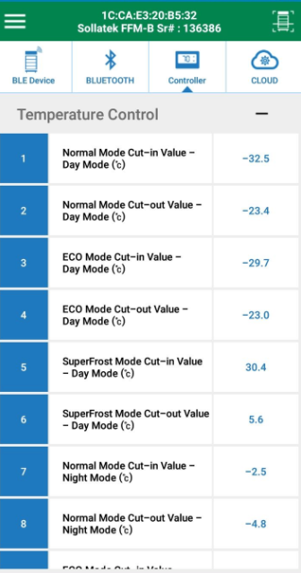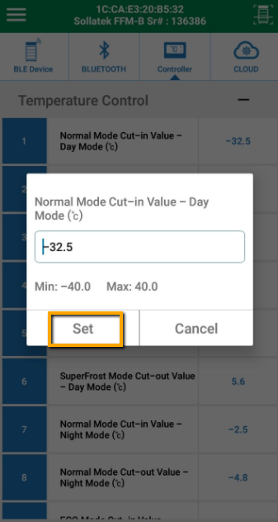

- For GBR4/FCA-3BB:

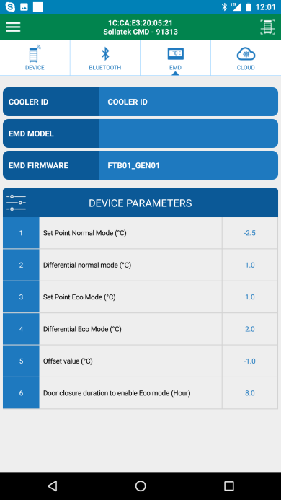

- For GBR1/FDE:

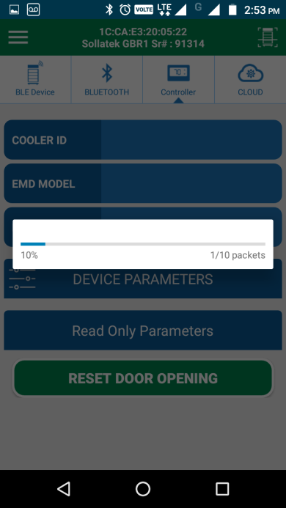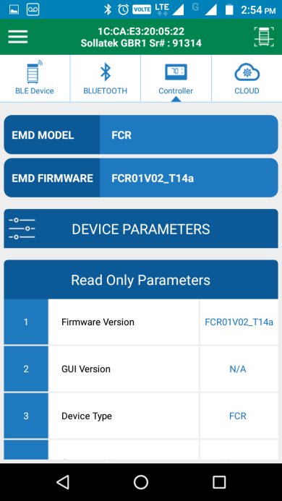
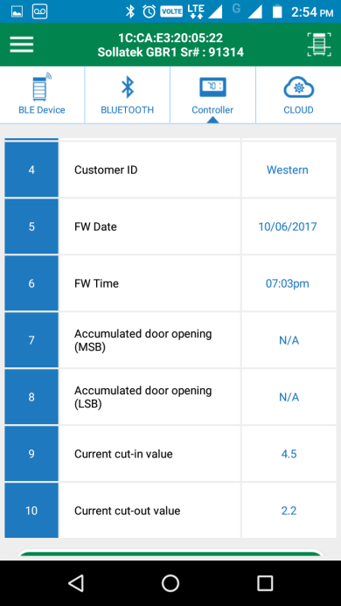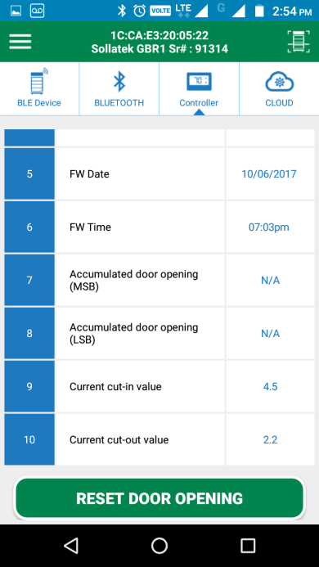

14 CLOUD TAB
- When click on Cloud tab, It will show information about Device stored on Cloud like Asset Name, Outlet Name, Device Serial No. and MAC Address. Internet connection is required for app to receive it from cloud.

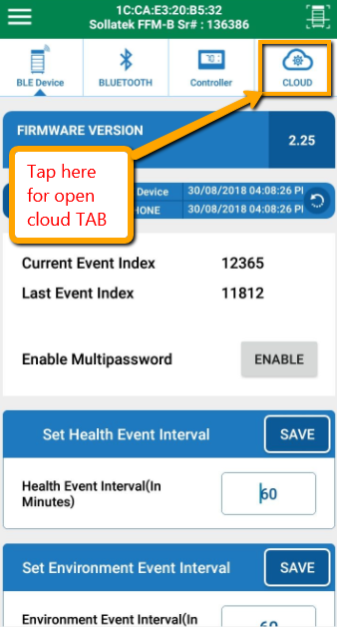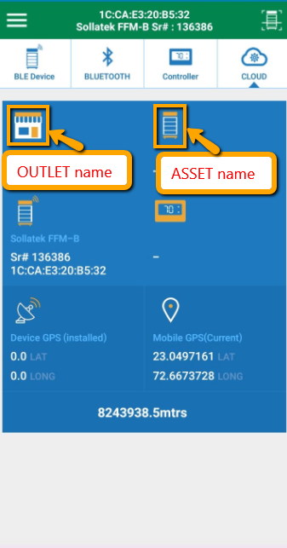

15 FIRMWARE UPGRADE OVER THE AIR (DFU)
- Whenever user connects to the device, Phone app will check for its BLE firmware version with latest firmware on cloud. If new firmware is available then app will suggest user to upgrade firmware with latest one as per below figure. User needs to tap the text to start DFU.
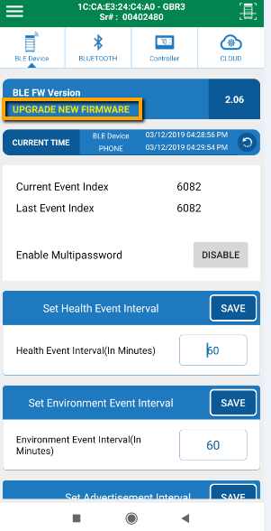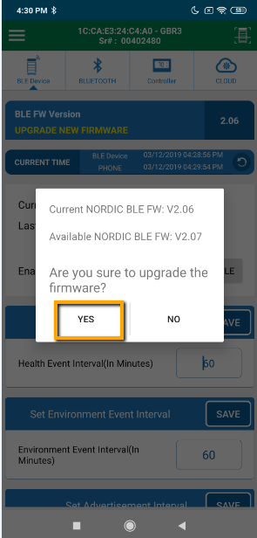
- After allowing for DFU, app will start DFU automatically.
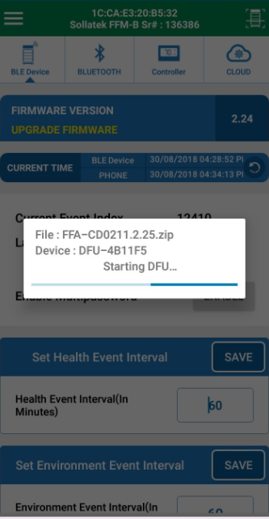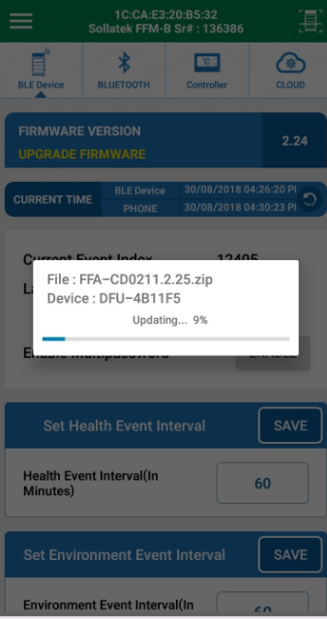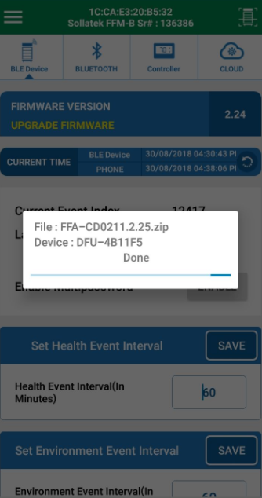

- After successfully upgrade, following screen will appear.

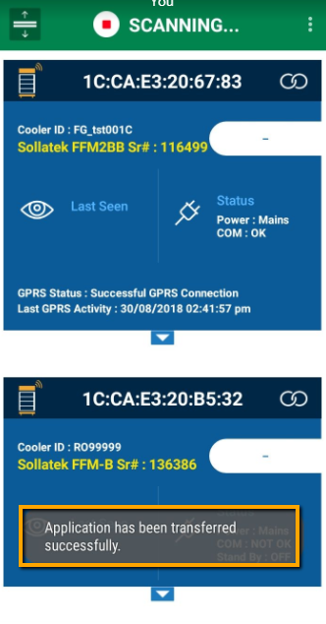

- User can verify latest firmware upgrade by making connection to device again and checking for firmware version.

16 STM FIRMWARE UPGRADE OF CONTROLLER
- Whenever user connects to the device, Phone app will check for controller firmware version also with latest firmware on cloud. If new firmware is available then app will suggest user to upgrade firmware with latest one as per below figure. User needs to tap the text to start upgrade new firmware.

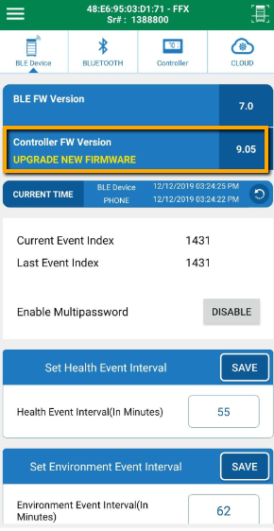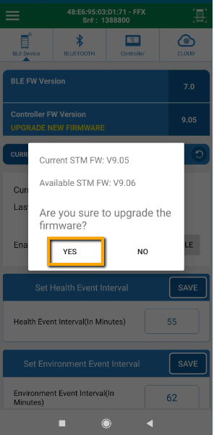

17 RUN VIRTUAL HUB FOR EVENT DATA UPLOAD ON CLOUD
- Virtual Hub (VH) is a service to upload logged event data on cloud.
- On scanning screen, click on menu button to open VH Configuration. Then tick to “Run as Service” and click on Apply button.

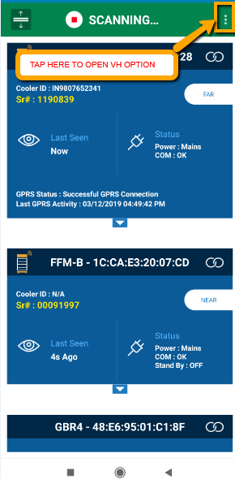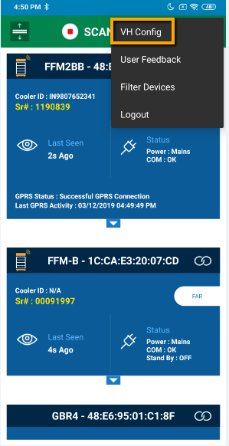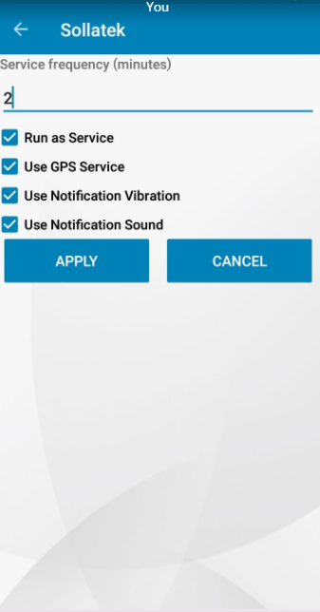

- When users TAP on Apply button then VH start at background, it can be verified from Notification.
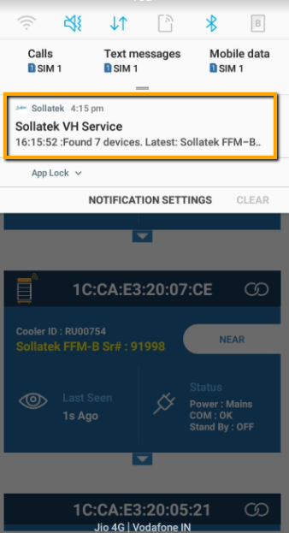

- App will start scanning of available surrounding devices and list out them on screen.
- App will try to connect each device sequentially to download event data.
- After successful event data downloading from device, “Data Downloaded and Clock SET” message will appear.
- After successful event data uploading on cloud, “Data Upload” message appear. “Waiting for next execution” message will appear at bottom side once app tried with all devices.
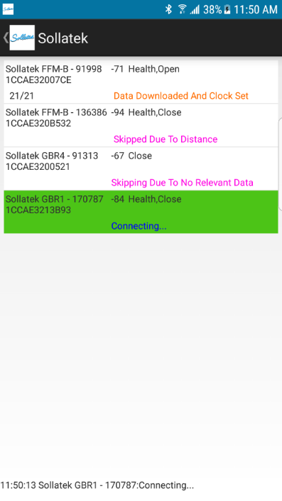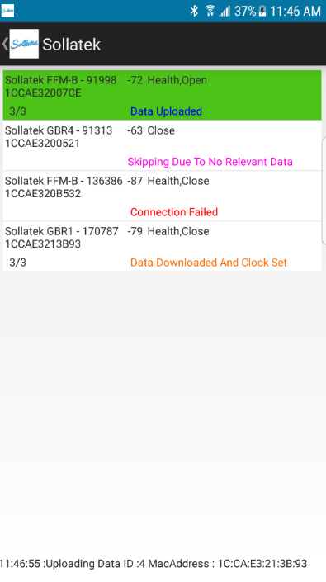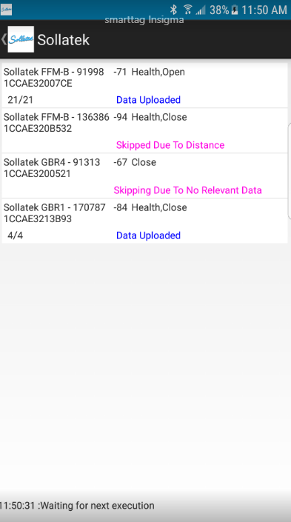

18 FILTER PARTICULAR DEVICE TYPE
- User can scan particular device type by using filter option.
- Click on Filter Devices option
- Select Device type which you want to search and then tap on apply button.
- After tap on apply button following screen appears.

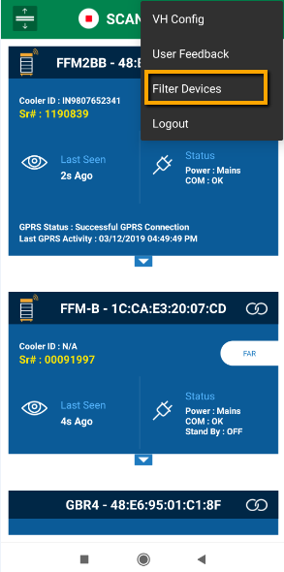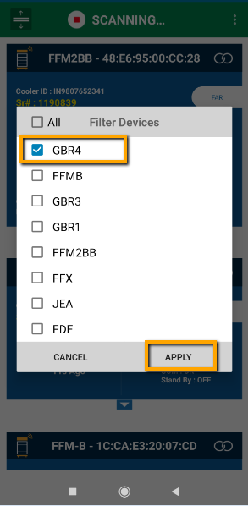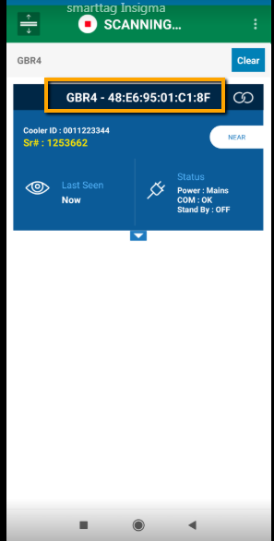

19 LOGOUT APPLICATION
- User can Log out the Application if required, otherwise after 24 hours auto logout occur and needs login again (with Internet Connectivity).
- TAP on Logout Button then click on Yes Button. After Logout, Login screen will appear.
- If users directly close the app, it means it will not be a Log out. On open the App, it will go directly to the scanning window.

